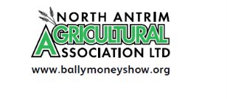
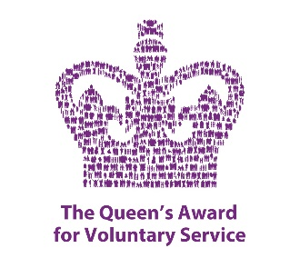
North Antrim Agricultural Association Ltd
Registered with The Charity Commission for Northern Ireland NIC107787

Dear Sponsor
Ballymoney Show, 2nd & 3rd June 2023

We have started to plan for our 2023 show, which will be held in our Showgrounds on Friday 2nd June and Saturday 3rd June 2023.
Each year our Show attracts a large turnout of visitors from across the Province, who enjoy a varied programme of events and exhibits.
We rely on the support of our Sponsors to ensure that this traditional family event can continue and would ask you to continue supporting us this way. We would like to take this opportunity to thank you for supporting us in the past and hope that this year you will again consider us favourably.
If you wish to sponsor us this year and would like your name included in our schedule and catalogue as a sponsor, we ask that you return the form by Friday, 17th March. If you require an invoice or wish to discuss further sponsorship opportunities please do not hesitate to get in touch.
We are holding our ‘Show & Press Launch’ at the Old School House (Part of St Patrick’s Parish Centre) in Ballymoney, on Tuesday, 18th April at 7.30pm to which you are cordially invited. This key event offers a valuable opportunity to meet the local media, and we would love to see you there.
Looking forward to hearing from you in the near future and please accept our sincere thanks once again for your continued sponsorship.

Yours sincerely
Anne McLaughlin
Secretary

