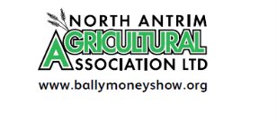

Dear Trader

Ballymoney Show, 3rd & 4th June 2022

After 2 years of being unable to run Ballymoney Show due to the coronavirus pandemic, we are delighted to let you know that we have started to plan for our 2022 show.
Applications are now open for trade stands and we are holding all our trade stand prices the same as before the pandemic as below:
INDOOR - £60 per stand
OUTDOORS - £50 for the first 10 feet plus £3 per extra foot

Please find attached an application form for a trade stand and we would be delighted to see you there at our show this year – on 3rd and 4th June.
You can either email back the form, post it, or use the following link to book your trade stand online:
https://showingscene.com/events/trade/ballymoney-show-2022-jun-2022-2/trade-goods

Payment can be made by Bank Transfer (details on form), cheque or by credit card if you book online.

Look forward to seeing you back at Ballymoney Show.

Yours sincerely

Anne McLaughlin

Secretary

Secretary: Anne McLaughlin, 282 Drones Road, Dunloy, Ballymena, BT44 9DU
Tel: 07713 519 928 or E-mail secretary@ballymoneyshow.org

