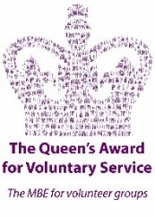
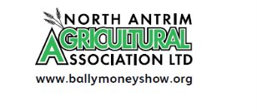

Dear Sponsor

Ballymoney Show, 3rd & 4th June 2022

After 2 years of being unable to run Ballymoney Show due to the coronavirus pandemic, we are delighted to let you know that we have started to plan for our 2022 show, which will be held in our Showgrounds on Friday 3rd June and Saturday 4th June 2022.

Each year our Show attracts a large turnout of visitors from across the Province, who enjoy a varied programme of events and exhibits.

We rely on the support of our Sponsors to ensure that this traditional family event can continue and would ask you to continue supporting us this way. We would like to take this opportunity to thank you for supporting us in the past and hope that this year you will again consider us favourably.

If you wish to sponsor us this year and would like your name included in our schedule and catalogue as a sponsor, we ask that you return the form by Friday, 18th March. If you require an invoice or wish to discuss further sponsorship opportunities please do not hesitate to get in touch.

We are holding our ‘Show & Press Launch’ at the Old School House (Part of St Patrick’s Parish Centre, see directions attached) in Ballymoney, on Wednesday 20th April at 7.30pm to which you are cordially invited. This key event offers a valuable opportunity to meet the local media, and we would love to see you there.

Looking forward to hearing from you in the near future and please accept our sincere thanks once again for your continued sponsorship.

Yours sincerely

Anne McLaughlin

Secretary

Secretary: Anne McLaughlin, 282 Drones Road, Dunloy, Ballymena, BT44 9DU
Tel: 07713 519 928 or E-mail secretary@ballymoneyshow.org

