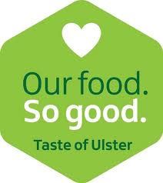
Food Marquee Booking Form 2022

Company Name: _______________________

Address: ____________

Postcode: ____________

Tel:

Contact Person: ____________

E-mail address: ____________

Type of product on your stand with details: ____________
_____________________________________________________________________________
_____________________________________________________________________________

Do you have insurance indemnifying Show Committee? Yes/ No____________________
Name of Insurer: ____________________________

Please enclose your food hygiene certificate
 | No of stands required | Total Cost £
Marquee Space £60 per stand (stands are 10’X10’)

Electricity will be available for a limited number of marquee stands to run low wattage equipment – if you require this please tick this box. The cost to supply this is £10. (We cannot guarantee this however we will make every effort to accommodate your request)

I enclose payment of £ for the above requirements
(include electricity at £10 if required)

(CHEQUES MADE PAYABLE TO NAAA Ltd. in £ STERLING)
Or alternatively you can pay by BACS (Sort code: 95-02-37, Account no: 71000047) Please remember to put your name on the BACS transfer.

Signed: Date:

PLEASE RETURN ALL FORMS BEFORE 1st May 2022

To: Show Secretary, Anne McLaughlin, 282 Drones Road, Dunloy, Ballymena, BT44 9DU
Tel 07713 51 99 28 or email secretary@ballymoneyshow.org
Ballymoney Show is committed to protecting your personal data and processing it only in accordance with legal requirements. We process your personal data as it is necessary for the performance of our contract with you to facilitate your entry to the Show. We retain your data in accordance with our retention schedule to simplify future applications.

